**Location:**

**Date and time of event:**

**Type of activity:**

**Nature of event (tick one option):** 🞏 Injury 🞏 Ill health 🞏 Incident 🞏 Near miss

**Harm – actual or potential (tick one option):** 🞏 Fatal / Major 🞏 Serious 🞏 Minor 🞏 Damage to property only

**Person(s) involved in event:** 🞏 Employee 🞏 Volunteer 🞏 Member of the public

**Name and position:**

**Address:**

**Contact telephone number:**

**Indicate position of injury:**

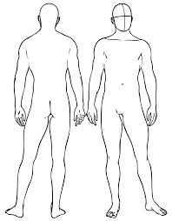

**Brief description of events** (what happened; where; details of injury / incident / near miss; emergency action taken; First Aid administered):

**Any witnesses?:** 🞏 Yes 🞏 No

If ‘yes’ provide name, position and contact telephone number:

**Investigation required? (tick ‘yes’ for serious / major / fatal event):** 🞏 Yes 🞏 No

**If ‘yes’ indicate level of priority:**  🞏 High 🞏 Medium 🞏 Low 🞏 Minimal

**Leader of investigation (Name and position):**

**CEO Signature: Date:**

**Reported by (Name and position):**

**Date: Signature:**

**Any immediate follow-up action taken (e.g. lighting fixed, paths de-iced) and details of who dealt with this:**

This section to be completed by line manager / team leader:

This section to be completed by H&S Committee:

**Any longer term managerial action(s) required to prevent recurrence:**

**RIDDOR reportable?:**  🞏 Yes 🞏 No

**If ‘yes’, provide date and time reported:**